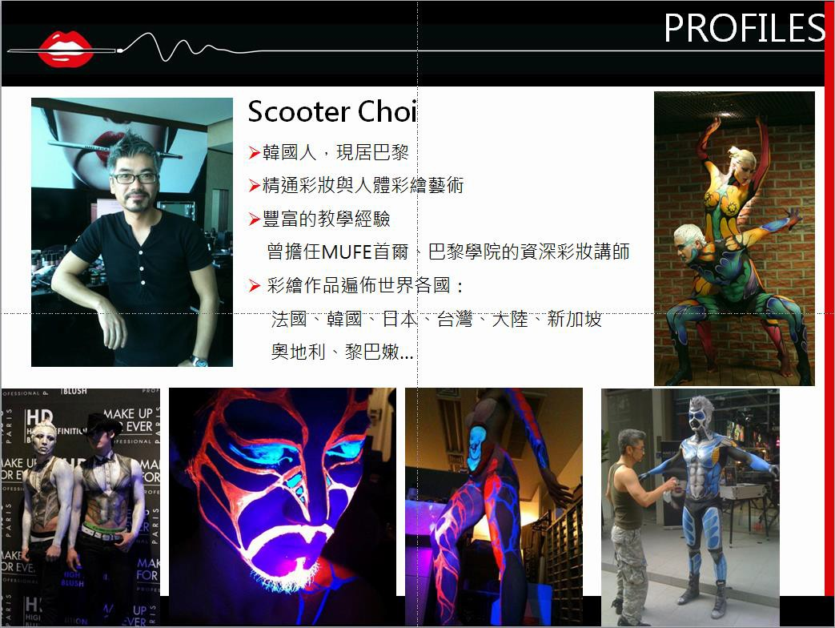

03/2015
05/2014
07/2013
11/2013
》 10/2012 09/2012
11/2011
05/2011
SLA Body Painting Exhibition,Paris, France

Make Up for Ever Artist Shadow Lunch Event,Body Painting Exhibition,Taipei,Taiwan. Body Painting Photo shooting with Damien Dufresne, Paris,France
Make Up For Ever Academy 10th Anniversary Body Painting Exhibition, Paris, France Make Up For Ever GRAND OPENING SHOW Body Painting Exhibition,Singapore
UAE Celebrity "Maya Diab Body Painting as TATTOO,Beirut, Lebanon
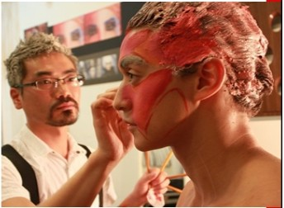Celebrity Makeup: Tilda Swinton, Lily c 他 Topper Grace and etc,Abu Dhabi Film Festival J-Man Body Painting Exhibition, Tokyo,Japan

04/2011’Nespresso Commercial Opening Body Painting Show,Seoul,Korea

05/2010
05/2009
04/2009
J-Man Body Painting Exhibition, Tokyo,Japan J-Man Body Painting Exhibition, Tokyo,Japan
Make Up Forever Body Painting Exhibition, Taipei,Taiwan

01/2009 Make Up Forever 25th Anniversary Body Painting Exhibition, Paris, France
05/2008 J-Man Body Painting Exhibition, Tokyo,Japan
08-09/2007 Makeup Artist for the Play Romeo and Juliet',Seoul,Korea

》05/2007 05/2007
04/2007

Make Up Forever Hyundai Department Store Body Painting Exhibition,Seoul,Korea J-Man Body Painting Exhibition (with Dany Sanz), Tokyo,Japan
Make Up Forever Brand Launching Show Body Painting Exhibition, Beijing,China

02/2007 Beauty Makeup, Eric Tibushi Fashion Show,Busan, Korea
》04-05/2006 Makeup A付ist for the Play Romeo and Juliet Seoul,Korea
》04/2006 Seoul Fashion A門ists Association Fashion Show Beauty Makeup, Seoul,Korea
11/2005-08/2008 Manager, Make Up Forever Boutique,Seoul,Korea
03/2005-10/2007 Professor of Art Makeup,Keimyung University,Daegu, Korea
07/2004 World Body Painting Festival,Seeboden,Austria (11th Place)

11/2003-12/2003 Little Theater of Alexandria,Virginia,Makeup Artist : "Shenandoah “Miracle Worker'

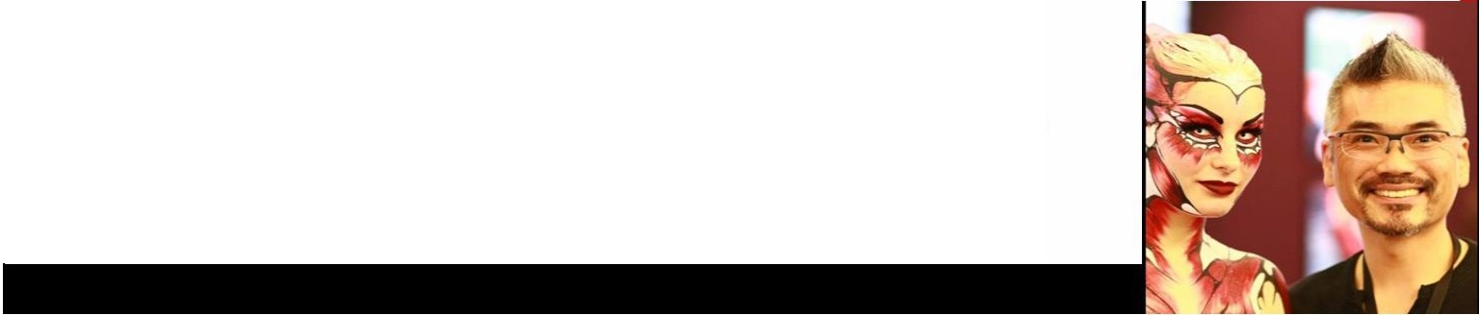
07/2003
》01/2003 10/2002
World Body Painting Festival,Seeboden, Austria, (9th Place)
Beauty Makeup,LOreal Hair Show,Paris,France
Beauty Makeup, Lee Hyoung-Hee Fashion Show,Paris,France

